COVID Vaccine Registration Guide

Home Page

JPMorgan as a firm thrives to keep health & wellbeing of all employees on top priority. In light of ongoing pandemic & as per government restrictions, it is mandatory for Organizations to ensure all employees accessing office premises are fully vaccinated.

Here is the guide for your reference on How & Where to update your vaccine information.

* How to upload vaccine information on JPMorgan Tool.
* How to check Vaccine status on the tool
* Common Errors & Solutions.

1. How do I upload my vaccination information (including booster vaccine) in the Vaccine Record Tool?



You can upload your information through the following steps:

* + Click on link <https://jpmchealthandwellness.com/> & login using your SSO credentials.
  + Select the appropriate statement and provide the required information as prompted.
  + Enter the date of your vaccine dose.
  + Continue to provide the required information for your subsequent vaccine doses.
  + Upload your vaccine card (PNG, PDF or JPEG files only).
  + When you are done, click “Submit”.
  + **You must declare 1st & 2nd dose on the tool along with your vaccine certificate in order to mark your vaccine status as Fully Vaccinated.**
  + Employees with Fully Vaccinated status only are allowed access to JPMorgan office.
  + You may also update your booster shot details if applicable.

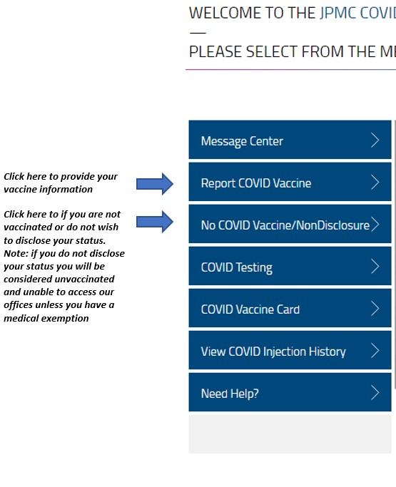

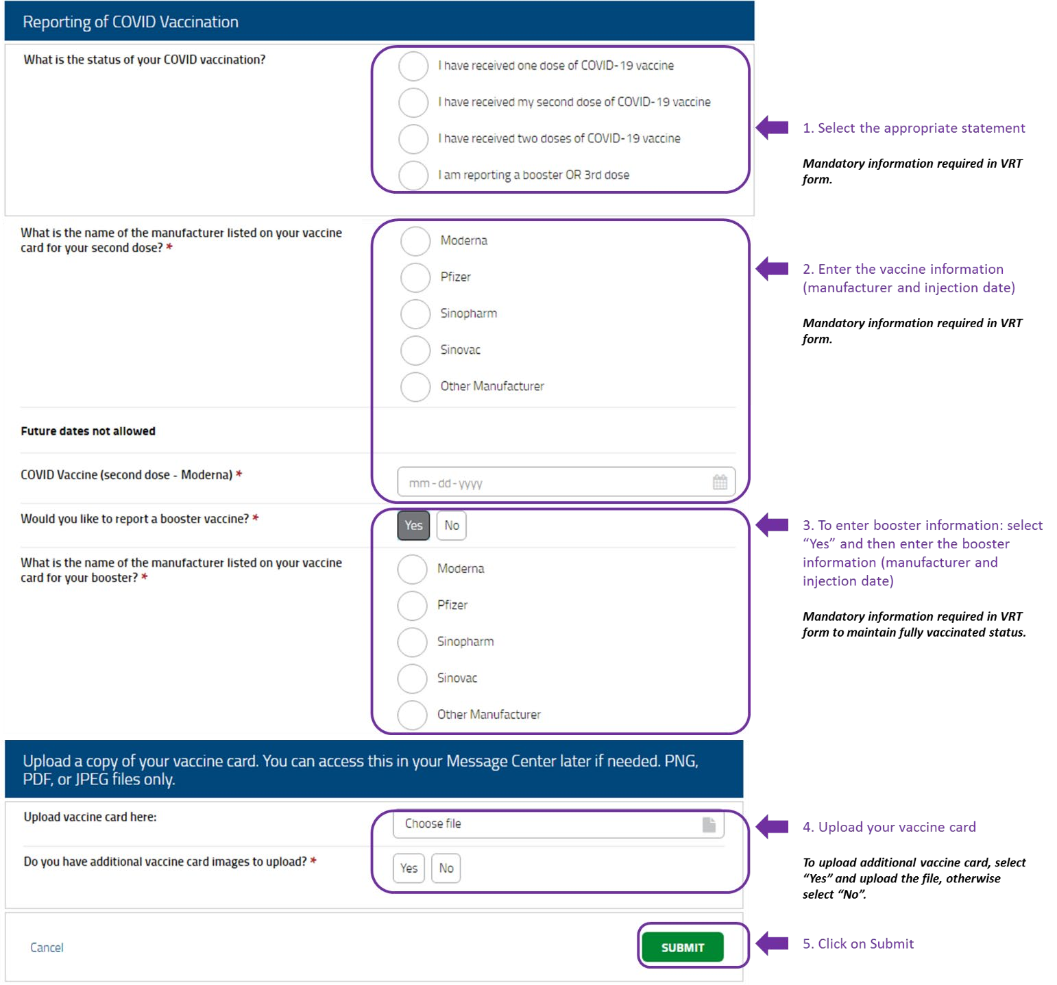

1. How do I check that my vaccine information has been submitted?



You can check whether your vaccine information has been submitted in the “View COVID Injection History”. Your vaccine information will be listed in the COVID Injection History section as shown in the sample screenshot.

If there are no details appearing under the COVID Injection History section, please re-submit your vaccine information using the VRT form (Refer to above screenshots.)

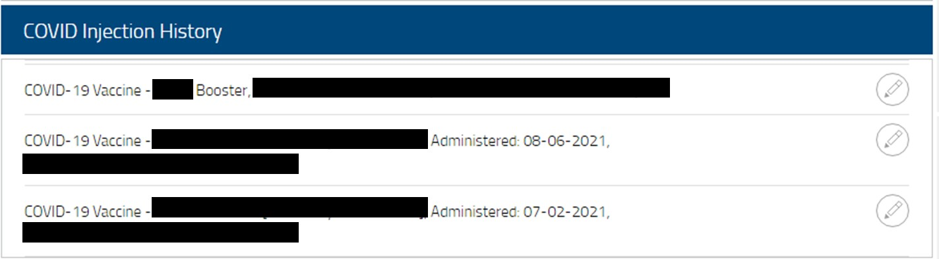

1. Common Errors & Solution:



I am getting this error: **“Login Ticket specifies an Invalid User”**

I am getting this error: **“Error Code: PP001”**

s

* Please wait and retry after 24-48 working hours for this issue to get fixed.
* If it still exists, then please call HR Answers at India ( Tollfree) – 0008-004-405-210 | International – 1-847-622-2565